**Udacity Self-Driving Car Engineer**

**Report**

* **Project:** Traffic Sign Classifier
* **Name:**  Shao Hongxu

**Let me just use some brief sentence to explain the thing I did, basically these are 6 big parts here:**

**Part 1:** import necessary lib

**Part 2:** identify Main function

**Part 3:** calculate model validation prediction accuracy

**Part 4:** using trained model to predict new image from web & provide top 5 predict possibility.

**Part 5:** Pre-processing techniques used and why these techniques were chosen

**Part 6:** Summary

**To be specific as below, you will find some note on Script, key take away and Area could be improved:**

**Part 1:** import necessary lib:

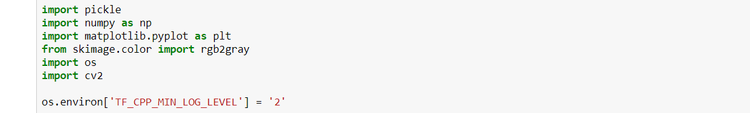

**Part 2:** identify Main function:

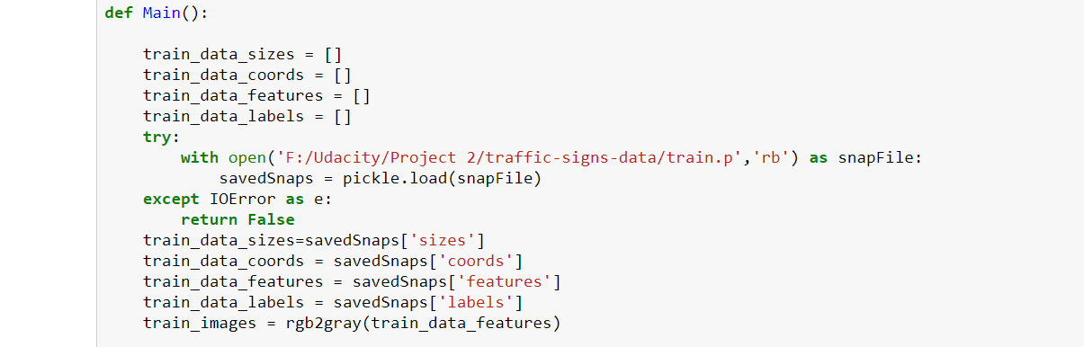

To archive the goal of deep learning Model, below is what I have done under Main function:

**2. 1:** Import data of training, validation, testing set. Original data is within ‘.p’ format, here we need to pull them and save into list format for further usage:



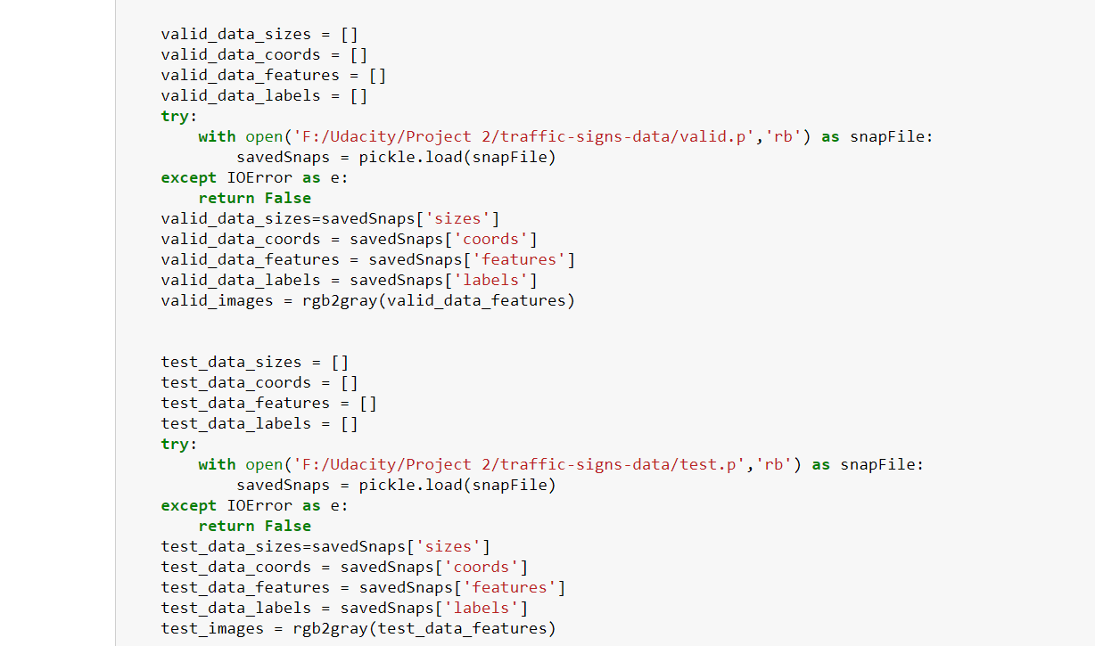

**-> Key take away:** while pulling original image data, it is necessary to convert colour image into grey image before using it for deep learning model. It will reduce the dimensions of input data. In the end, the benefit would be faster training time.

**-> Area could be improved:** not all the provided data used in this code always, for those data no longer used any more, list to be cleaned to save computing Memory.

More importantly, if we could enlarge original data, it would be very helpful, like project spec recommended, rotation, translation, zoom, flips, and/or colour perturbation etc. will decide later whether to do it or not depends on the time & accuracy.

**-> Result:**

*Original data:*

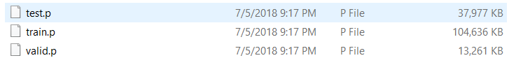

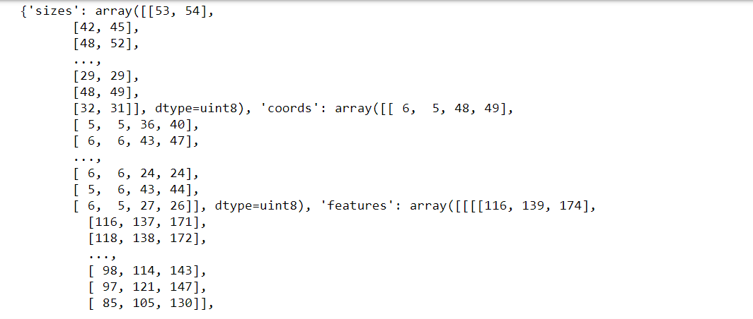

*Data after pulling into python:*

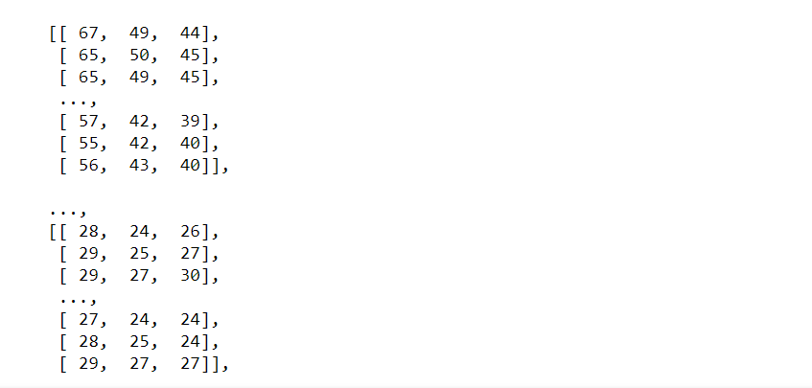

**2. 2:** Visualize the training data – image label



**-> Result:**

*Summarise the training label, realized in total there are 42 different label sets, so that 43 output classifiers needed for the classification model:*



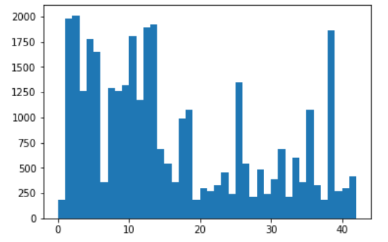

**2. 3:** using image size & border points, to crop the image into only traffic sign.

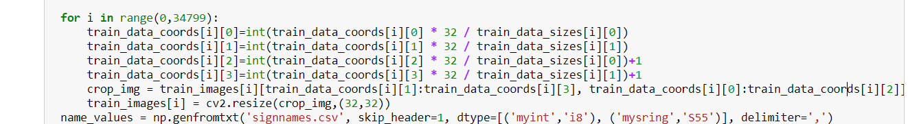

**-> Key take away:** action here helped with increasing accuracy of training model.

**2. 4:** choose some random images and list down shape and min/max value from image data:

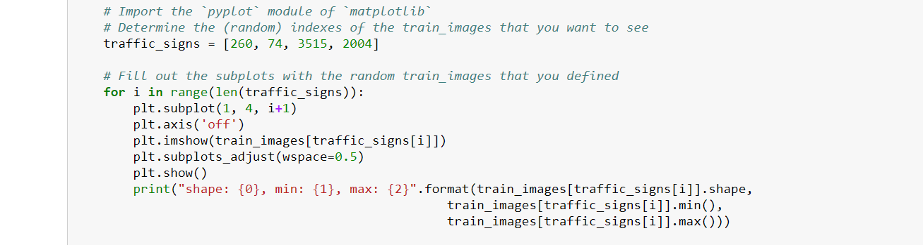

**-> Key take away:** as mentioned from project Spec, all images data provided have already been converted into 32*32 shape.

Still I just put a checking point here in case any other similar model has different shape of images, we can have a basic sense of how various the images’ shape are.

**-> Area could be improved:** here we can also draw a chart to show how many image there are in total etc.. Just from better understanding data perspective.

**-> Result:**

*4 sample Images:*

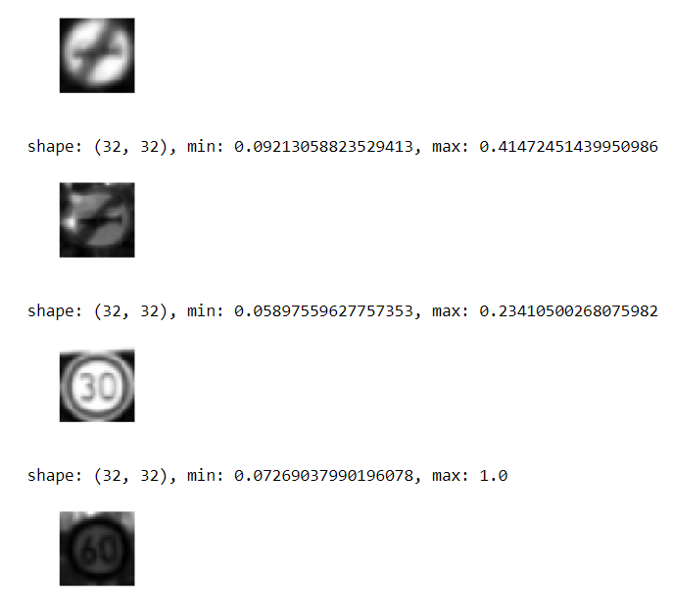

**2. 5:** to initiate a training model using TensorFlow:

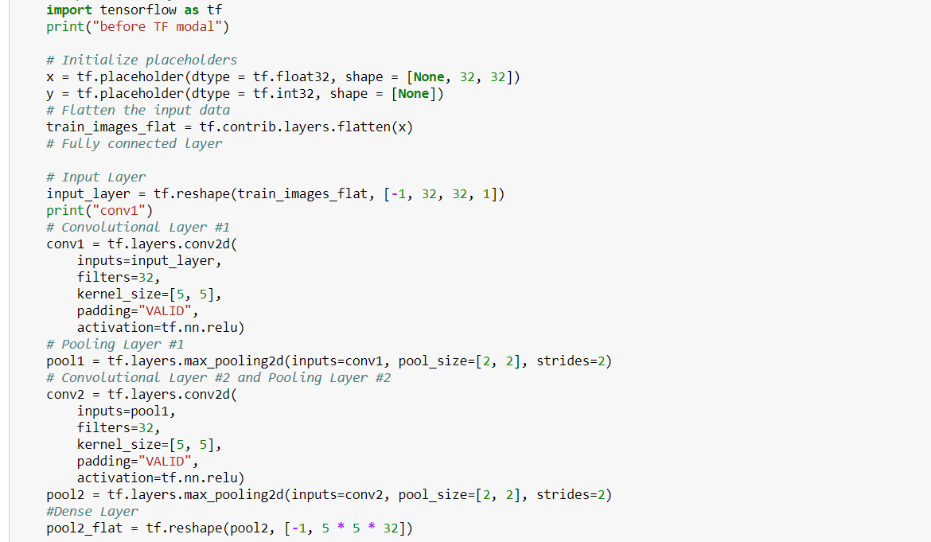

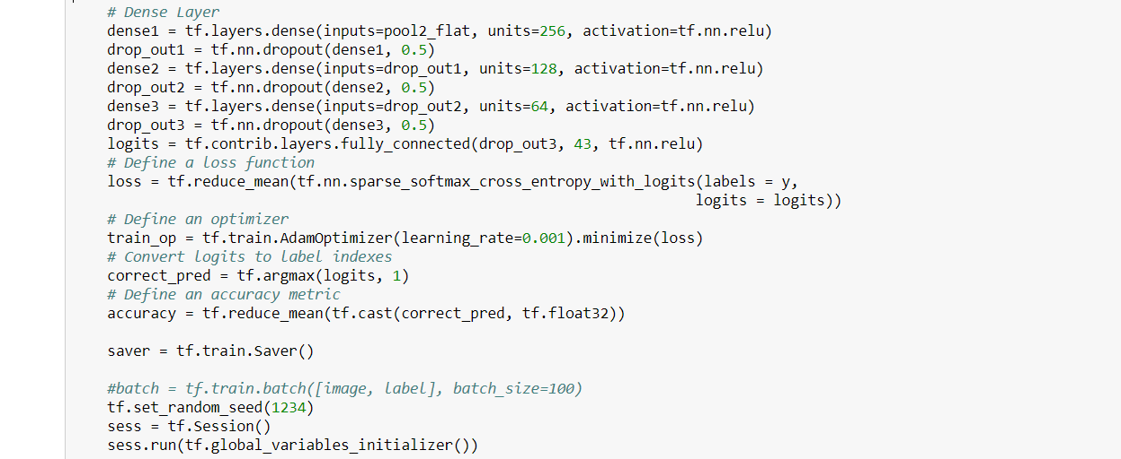

**-> Key take away:**

This is the most important area apparently, architect here obviously will impact the final accuracy in the end. Let’s look at the model overview:

* **Input layer:** [-1, 32, 32, 1]
* **1st layer:** flatten layer
* **2nd layer:** Conv2d layer with filters=32, kernel_size=[5, 5], padding="VALID"
* **3rd layer:** max_pooling2d layer with pool_size=[2, 2]
* **4th layer:** Conv2d layer with filters=32, kernel_size=[5, 5], padding="VALID"
* **5th layer:** max_pooling2d layer with pool_size=[2, 2]
* **6th layer:** reshape layer, converting data into [-1, 5 * 5 * 32]
* **7th layer:** 256 units, with 0.5 dropout
* **8th layer:** 128 unit, with 0.5 dropout
* **9th layer:** 64 unit, with 0.5 dropout
* **Output layer:** 43

From input data size 32*32, we use:

2 Con2d layer

2 max_pooling2d layer

1 reshape layer

3 normal connecting layer

Reduce data size into 43 classifiers in the end.

**-> Area could be improved:** here is the key area can be improved, as all other machine learning/ deep learning model, a bad model will not come out with any high accuracy prediction rate:

- how many levels of layer?

- how many units for each level of layer?

- dropout rate? here to be 0.5

- etc.

This part is the core of Machine learning/ deep learning. Also GPU, TPU play an important role of training out of the better model accuracy.

First time I was using laptop with 16GB CPU (no NAVIA GPU), 98% CPU usage stopped me doing that again since it may destroy the machine.

Second time I was using my desktop with NAVIA GPU 1080. It takes only 40min to complete 5000 echoes. And with not bad accuracy in the end, so the model architect mentioned above can work to a certain extend.

**2. 6:** Initiate model weight variables, and to set up run Epoch into 5000 times, with Batch size as 2000.

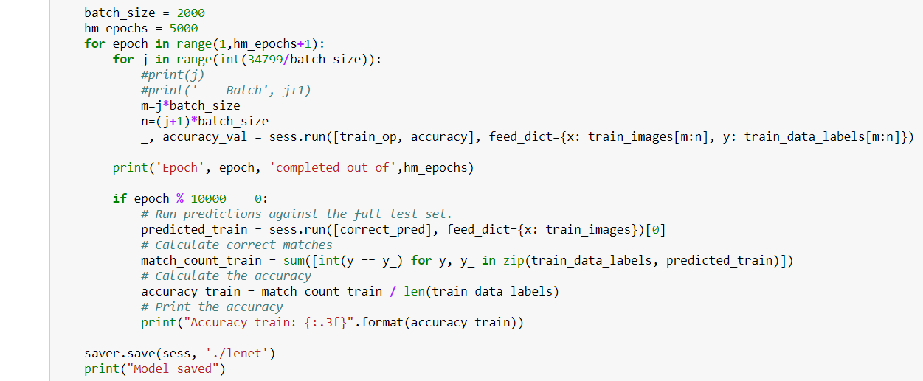

**2. 7:** once model training completed, to show the prediction of 10 random images

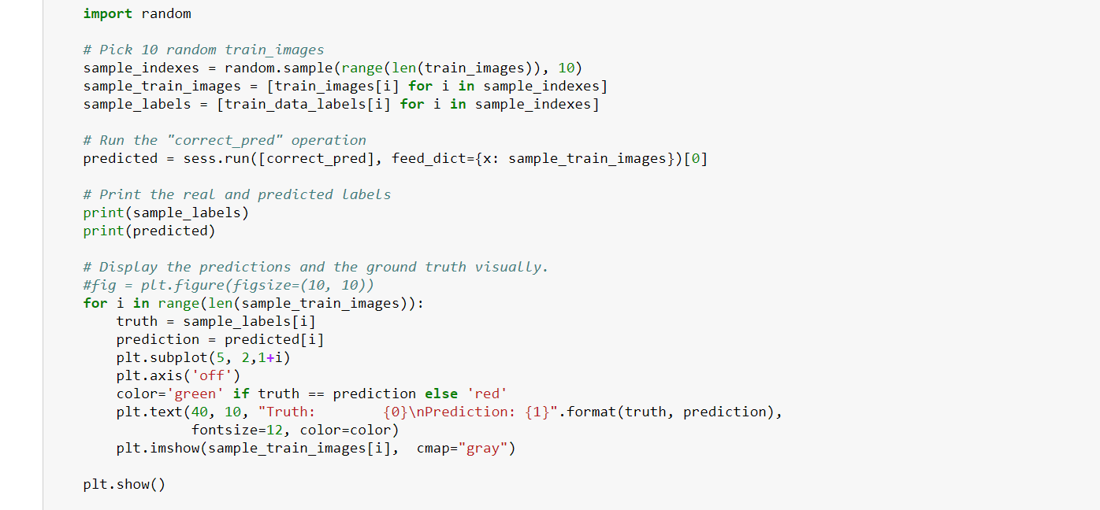

**-> Result:**

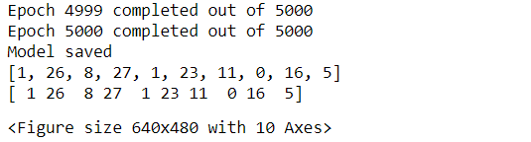

**Part 3:** calculate model prediction accuracy:

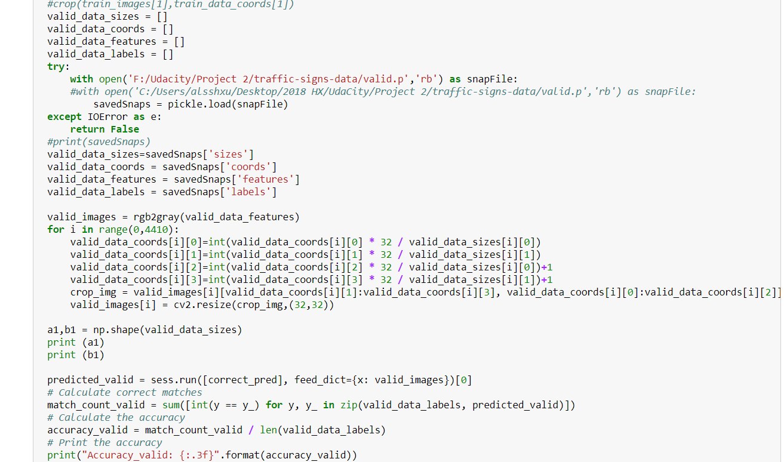

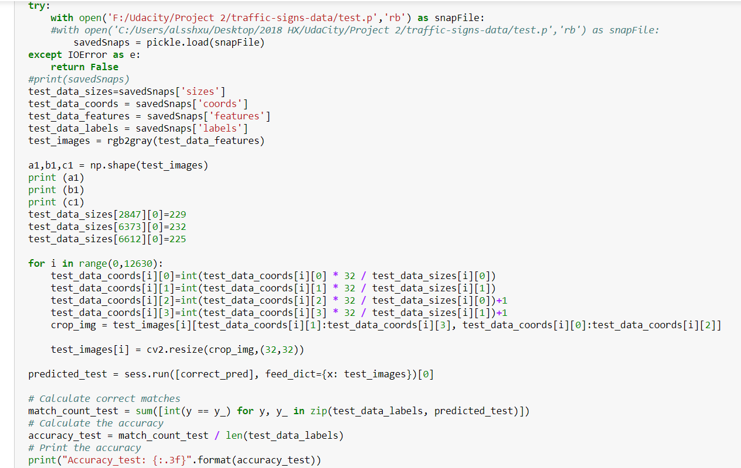

Result:

After 5000 echoes:

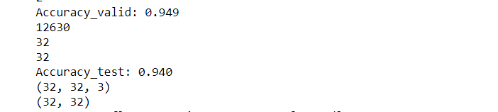

**Part 4:** using trained model to predict new image from web & provide top 5 predict possibility.

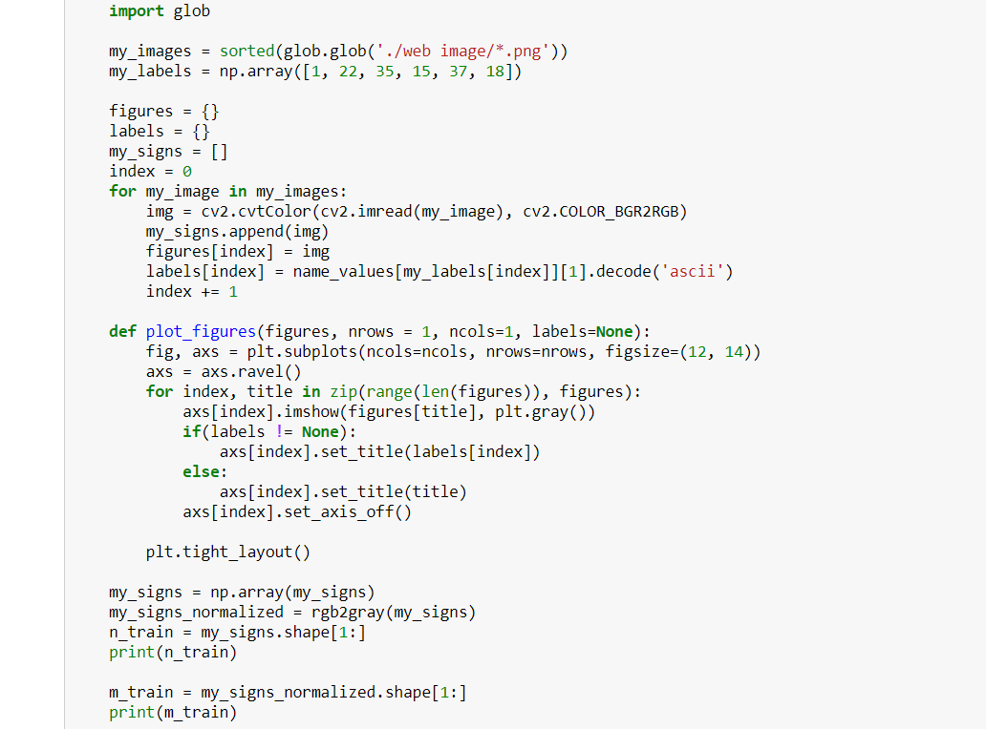

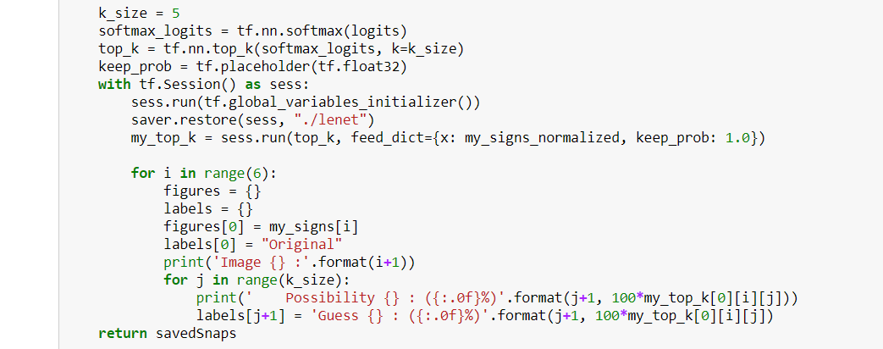

Result:

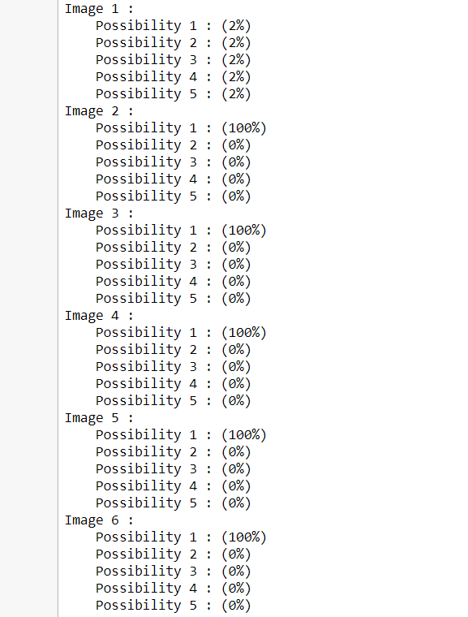

**Part 5:** Pre-processing techniques used and why these techniques were chosen:

* Con2d layer:

**Reason/ Benefit:** to reduce input data size, but not impact image information. Weight as a 5*5 matrix. This weight shall now run across the image such that all the pixels are covered at least once, to give a convolved output. The weight matrix behaves like a filter in an image extracting particular information from the original image matrix. Therefore weights are learnt to extract features from the original image which help the network in correct prediction.

* max_pooling2d layer:

**Reason/ Benefit:** Pooling is done for purpose of reducing the spatial size of the image. And also independently on each depth dimension, the depth of the image remains unchanged. The most common form of pooling layer generally applied is the max pooling.

**Part 6:** Summary

These are the steps I could think of for project 2, as a base line. Still a lot of improvement needed to achieve a better accuracy.

The key area could be improved is:

1. Original data expansion

if we could enlarge original data, it would be very helpful, like project spec recommended, rotation, translation, zoom, flips, and/or colour perturbation etc.

1. Model architecture enhancement

- how many levels of layer?

- how many units for each level of layer?

- dropout rate? here to be 0.5

- etc.

1. In the end, after 5000 echoes, validation accuracy becomes 94.9% using desktop GPU.